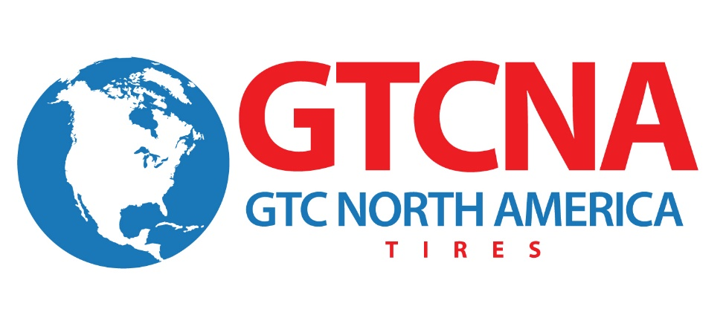

FOR IMMEDIATE RELEASE

Contact: Julie Safreed Andy Morrow
EditorPressRoom GTC North America
330-494-6999 330-418-5693
Jsafreed@editorpressroom.com andym@gtcna.com

GTC North America Plans New Product Introductions at SEMA 2014

Canton, OH (October 31, 2014) – GTC North America announced today that it will introduce a number of new Samson and Advance tire models at SEMA 2014, November 4-7, 2014 in Las Vegas, Nevada. “We manufacture a complete line of Commercial Truck, Industrial, Farm and Specialty Tires,” said Karl Lammlein, director of sales. GTC North America. “Our distributors can mix and match all the products we produce on one container delivered to their location. We’ve become a one-source supply for truck/industrial/farm specialty tires.”

Many GTC North America tractor and trailer truck tires are Smartway verified. Smartway verified tires are low rolling resistance tiresthat have been determined by the U.S. Environmental Protection Agency to provide an estimated fuel savings of 3% or greater.

New tire models showcased at SEMA (booth # 40221) include:

- Advance and Samson brand Steer, Drive and Trailer Tires
- Advance and Samson brand Solid/Giant Solid/Press On Solid Industrial Tires

In addition to the new tire models, the complete line of Advance and Samson Brand categories will be on display:
- MTR/Mobile Crane
- Bias Truck
- OTR/Logging
- Industrial
- Farm/Skid Steer
- Solid/Giant Solid

About GTC North America

GTC North America, Inc., based in Canton, Ohio, is a wholly owned subsidiary of the Chinese-based Guizhou Tyre Company LTD that markets the ADVANCE and SAMSON tire brands. A leading OE and replacement tire company, GTC North America manufactures over a thousand types/sizes of Truck, Bus, OTR, Agricultural, Industrial and Solid tires (both radial and bias.) GTC North America has obtained the ISO9001, ISO14001, American NHTSA DOT certification, European E-Mark and the Gulf Standards GCC certification. More information about the company can be found at www.GTCNA.com .
# # #

