Contact:
Rod McGregor
330-418-1124
rodmcgregor@winegardautomotive.com
This press release and photographs can be downloaded at www.editorpressroom.com/winegard
Tiffini Brockway
319-754-0696
tbroc@winegard.com
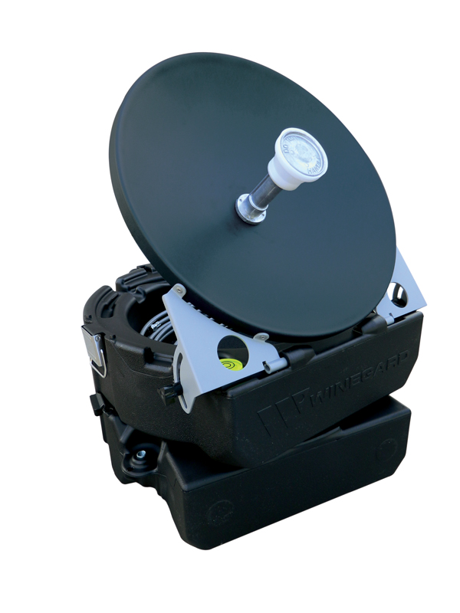
The WINEGARD CARRYOUT MP1 Manual Portable Satellite TV Antenna stores in a compact durable case that doubles as the antenna base when in-use.

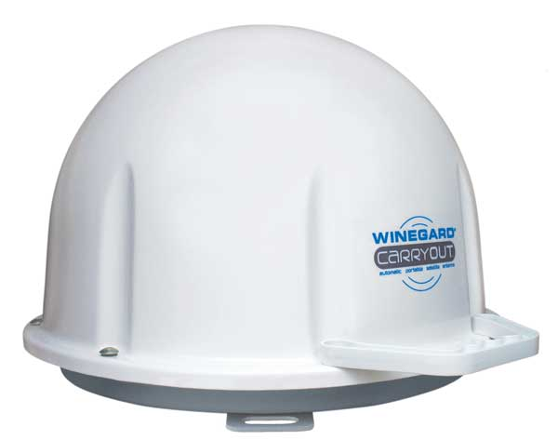
The WINEGARD CARRYOUT Automatic Portable Satellite TV Antenna offers extremely fast and easy satellite acquistion.

The

Winegard Company Introduces Satellite Antennas for the Tailgating Market
BURLINGTON, Iowa – (January 11, 2012) – Winegard Company, an innovator and leader in television antenna and mobile satellite television systems has introduced satellite antennas and accessories that offer QUICK and EASY setup for the tailgaters.
The Winegard CARRYOUT TM Automatic Portable Satellite TV Antenna is the most compact automatic portable satellite TV antenna on the market today. A perfect partner for tailgating, RVers, camping, boating, races, wooded areas, cabins and vacation homes, the CARRYOUT antenna can be used anytime, anywhere. Simply connect to a receiver and plug into a 12V power source and it’ll do the rest! No remote or controls needed.
“Winegard has a long history of providing the highest quality of mobile television antennas for the RV market, and the CARRYOUT is a natural for tailgaters” said Aaron Engberg, director, mobile products, Winegard.
Featuring DVB technology for extremely fast and accurate satellite acquisition, the CARRYOUT automatically locks on and switches between the desired satellites. The CARRYOUT is compatible with all major satellite providers and receives all standard and HD programming for DISH Network® and Bell TV, as well as standard DIRECTV® programming.
An easy grip handle provides for effortless carrying and added security. The CARRYOUT runs off of 12V and plugs into a vehicle’s standard power outlet or Winegard’s 110V power inverter. Unit weight is only 13.5 lbs. With an MSRP of $699.00, the CARRYOUT (GM-1518) is the most affordable automatic portable mobile entertainment option on the market.
The CARRYOUT® MP1 Manual Portable Satellite Antenna is extremely compact and weighs only nine pounds, making it ideal for tailgating, races, RVing, camping, traveling and other outdoor activities.
“Extensive market research showed us that there is a definite niche in the market for consumers who want a portable and affordable satellite TV antenna,” said Aaron Engberg, director of Winegard’s mobile products.
The manual antenna stores in a compact, durable case that doubles as the antenna base when in-use. The case features an easy-grip handle for carrying or locking down. A bubble level, compass and elevation markings molded into the base make set-up quick and easy.
The CARRYOUT MP1 comes with 25 feet of coax cable to allow for optimal antenna placement. The case with antenna measures 16’x x 18.5”h x 10”d. The unit supports two receivers (not included), and it is compatible with DIRECTV® (standard only) and DISH® Network (standard and HD). It has a suggested retail price of $199.00.
About Winegard

Winegard Company designs and manufactures world class antenna products for both satellite and over-the-air multi-media signal reception. With more than 55 years of antenna design, testing and manufacturing experience, Winegard’s innovative solutions have shaped the industry for home, recreational vehicle, truck, marine, medical, and automotive antennas. Winegard also offers commercial VSAT 2-way antennas that provide real-time broadband communication solutions for extreme and remote environments to oil and gas industries and to military and emergency response teams. A pioneer in antenna technology, Winegard has designed more than 1,000 different antenna models with more than 60 product patents, making Winegard products the benchmark for quality and performance.

Winegard Company is a privately held company led by Randy Winegard, son of founder, John Winegard and is headquartered in Burlington, Iowa. To learn more about Winegard, visit http://www.winegard.com or call 800-288-8094.

# # #

