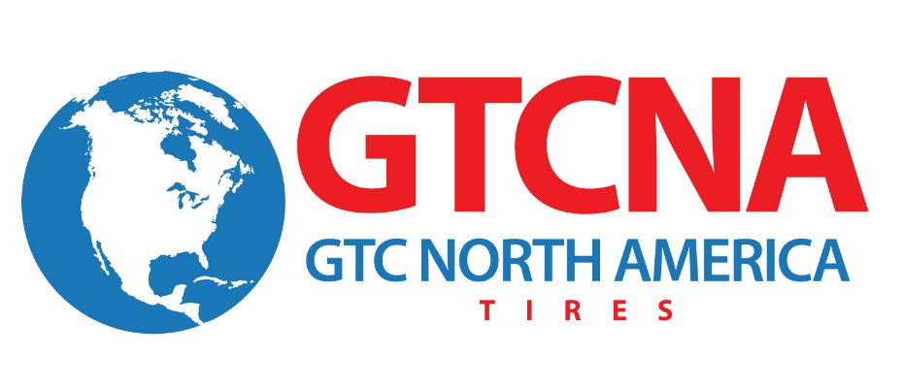

FOR IMMEDIATE RELEASE

Contact: Julie Safreed Andy Morrow
EditorPressRoom GTC North America
330-494-6999 330-418-5693
Jsafreed@editorpressroom.com andym@gtcna.com

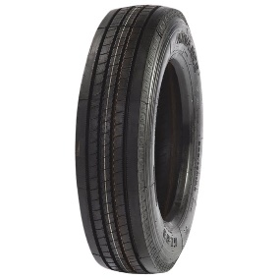

(Caption: Advance/Samson SmartWay verified tires reduce fuel consumption. High Resolution photos are available at http://editorpressroom.com/senturytire/gtcna_photos.html )

GTC North America Introduces New SmartWay Verified Tires
Canton, OH (October 31, 2014) – GTC North America announced today that it will introduce a number of new SmartWay-verified Advance and Samson branded tires. “Many customers are looking for a value-priced tire that can reduce fuel consumption,” said Karl Lammlein, director of sales. GTC North America. “The EPA has determined that verified tire models can reduce NOx emissions and fuel use by 3 percent or more, relative to the bestselling new tires for line haul class 8 tractor trailers.” SmartWay verified tires can be found at the EPA website, http://www.epa.gov/smartway/forpartners/technology.htm .

The following Advance/Samson tires are SmartWay verified:
Steer
- GL283A
- GL282A
- GL115S

Drive
- GL283A
- GL293D
- GL282A
- GL266D
- GL268D
- GL160D

Trailer
- GL285T
- GL185T
- GL155T

The SmartWay program establishes credible performance criteria and reviews test data to ensure that vehicles, equipment and technologies will help fleets improve their efficiency and reduce emissions.

About GTC North America

GTC North America, Inc., based in Canton, Ohio, is a wholly owned subsidiary of the Chinese-based Guizhou Tyre Company LTD that markets the ADVANCE and SAMSON tire brands. A leading OE and replacement tire company, GTC North America manufactures over a thousand types/sizes of Truck, Bus, OTR, Agricultural, Industrial and Solid tires (both radial and bias.) GTC North America has obtained the ISO9001, ISO14001, American NHTSA DOT certification, European E-Mark and the Gulf Standards GCC certification. More information about the company can be found at www.GTCNA.com .
# # #

