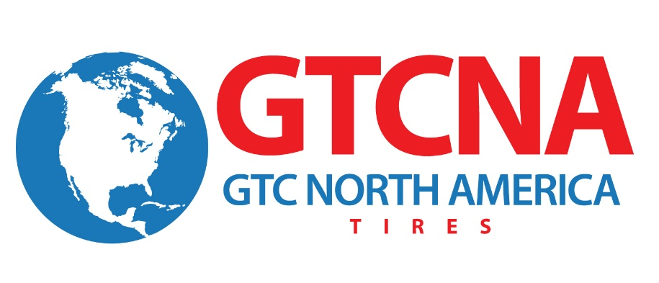

FOR IMMEDIATE RELEASE

Contact: Julie Safreed Andy Morrow
EditorPressRoom GTC North America
330-494-6999 330-418-5693
Jsafreed@editorpressroom.com andym@gtcna.com

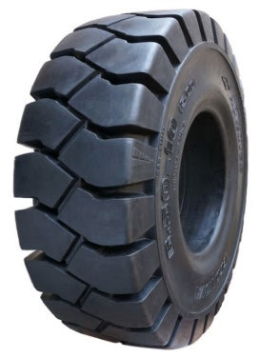
(Caption: GTCNA Solid Tires Help Reduce Downtime. High Resolution photos are available at http://editorpressroom.com/senturytire/gtcna_photos.html )

GTC North America Introduces Complete Line of Solid Tires
Canton, OH (October 31, 2014) – GTC North America announced today that it will increase the number of solid tires in its product line. “Solid tires are becoming more popular as companies look for a tire that reduces downtime,” said Karl Lammlein, director of sales. GTC North America. “Solid tires are great for extreme environments and are built to perform.”

GTC North America markets the following categories Advance/Samson Solid Tires:
- Solid
- Giant Solid
- Press On Solid

“More of our tire distributors are expanding their business to include the industrial market. And with GTC North America, our customers can Mix and Match their Solid tire order in one shipping container with our other tire categories, including, MTR/Mobile Crane, Bias Truck, OTR/Logging, Industrial and Farm/Skid Steer.” added Lammlein.
About GTC North America

GTC North America, Inc., based in Canton, Ohio, is a wholly owned subsidiary of the Chinese-based Guizhou Tyre Company LTD that markets the ADVANCE and SAMSON tire brands. A leading OE and replacement tire company, GTC North America manufactures over a thousand types/sizes of Truck, Bus, OTR, Agricultural, Industrial and Solid tires (both radial and bias.) GTC North America has obtained the ISO9001, ISO14001, American NHTSA DOT certification, European E-Mark and the Gulf Standards GCC certification. More information about the company can be found at www.GTCNA.com .
# # #

