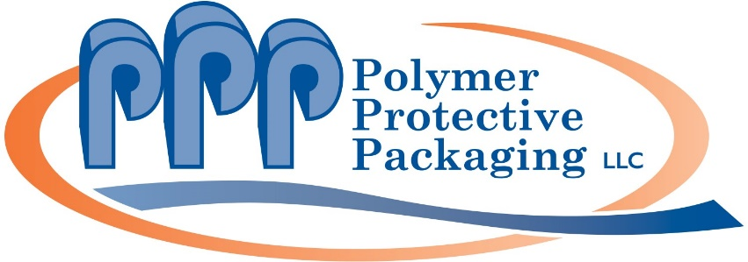
5285 Edgewater Drive
Allendale, MI 49401
Website: www.polymerpkg.com/polymer-protective-packaging

Contact: Rod McGregor / 330.418.1124 / rodmcgregor@crowlinc.com

Feb. 1, 2019
FOR IMMEDIATE RELEASE
(High resolution image and caption included on page 2. Release is also available at https://editorpressroom.com/polymerpackaging and photo available at https://editorpressroom.com/polymerpackaging.)
POLYMER PROTECTIVE PACKAGING OFFERS A MYRIAD OF POLYETHYLENE (PE) BAGS
Allendale, MI--As a polyethylene (PE) bag manufacturer, Polymer Protective Packaging is expert at wicketed bags, staple pack bags, die cut bags/sheets, side-weld industrial cut bags, printed bulk bags, coextruded (coex) lip/tape poly mailers and other specialty and custom products.
Our printed bulk bags and other polyethylene products consist of LDPE, HDPE, LLDPE, coextruded films, and other types of polyethylene materials. We also convert polyolefin, polypropylene, and other types of polyethylene or polypropylene based substrates.
“PE bags from Polymer Protective Packaging are transparent, strong, flexible and puncture, impact and tear resistant,” said Jessie Larabel, Vice President. “Other advantages include cost savings, moisture barrier, chemical resistance and food grade availability. “

PE bags from Polymer Protective Packaging can be specified in gauges from .23 mil – 8 mil, low-density polyethylene (LDPE), high-density polyethylene (HDPE), linear low-density polyethylene (LLDPE), coextruded polyethylene, printed polyethylene and laminated films.

Types of bags available include printed bulk bags, wicketed bags, individually cut bags, perfed on roll bags, die cuts, staple packs, sheets, perfed on roll sheets, lip & tape bags, compartment bags and poly mailers.

Polymer Protective Packaging provides custom protective packaging that protects products from shock, vibration effects and surface abrasion. For more information, call 616.275.0991 or visit www.polymerpkg.com/polymer-protective-packaging.

(Photo cutline)
Polyethylene bags from Polymer Protective Packaging are transparent, strong, flexible and resistant to puncture, impact and tear.

--30--

