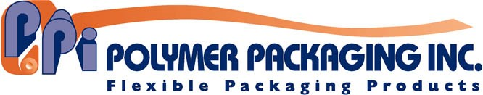

Contact: Larry L. Lanham / 330-323-7373 / larry.lanham@polymerpkg.com

FOR IMMEDIATE RELEASE
Feb. 15, 2019

CO-POLYMER-X IS A LOWER COST, HIGH-QUALITY REPLACEMENT TO EXISTING FILM

Massillon, OH—Co-Polymer-X from Polymer Packaging is a lower cost, high-quality replacement to standard film used in any application where plain, unprinted film is being used.
Co-Polymer-X is a stronger but thinner, light-weight film alternative to conventional film, making it ideal for food and industrial packaging applications. It increases strength yet saves money and reduces plastic consumption. Applications include poly bags, gaylord liners, bin and case liners, dust covers, pallet shrouds, box liners, furniture covers and shrink film.
Manufactured in SQF-approved facilities, Co-Polymer-X is produced with premium resins using advanced multi-layered extrusion technology. It also is available in industrial grades.
Co-Polymer-X is environmentally friendly and delivers source reduction up to 50% over existing films. It is available in thickness range of .0003 to 10 mil and size range from 14-125 inches wide.
“Polymer Packaging offers free lab testing that allows the company to reverse engineer your existing film to determine what your current film is and why it works,” said Larry L. Lanham, CEO. “With this information, we are able to design a less expensive but stronger Co-Polymer-X alternative and give you a side-by-side graphical specification comparison.”
“Combined with our 100% guaranteed trial order, all guesswork is eliminated in utilizing this superior product,” Lanham said. “The evaluation and trial process from start to finish can be accomplished in two weeks or less with typical full orders also supplies in two weeks or less.”
Polymer Packaging is a leader in developing flexible packaging solutions to the consumer products industry. For more information call 330-359-1421 or visit www.polymerpkg.com/polymer-packaging-inc.

—30—

(Photo cutline)
Co-Polymer-X offers a variety of benefits over standard film, making it ideal for food and industrial packaging applications.

