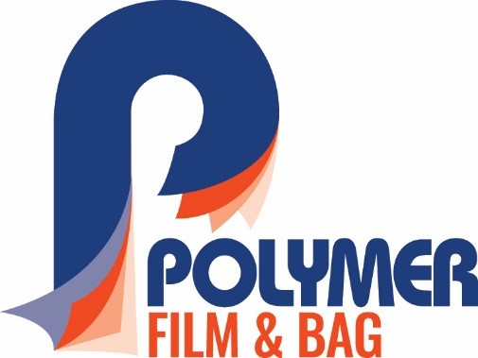

Contact: Chris Thomazin / 330-830-6046 / chris.thomazin@polymerpkg.com
Rod McGregor / 330-418-1124 / rmcgregor@crowlinc.com

FOR IMMEDIATE RELEASE

POLYMER FILM & BAG COMMENCES PRODUCTION OF
MULTILAYERED FILMS ON SECOND EXTRUSION LINE

MASSILLON, OH—Polymer Film and Bag, a division of Polymer Packaging, Inc., begins production of multilayered film for the flexible packaging industry on the second of two co-extrusion lines.
“We are very excited to be back in the extrusion business utilizing the very latest W & H blown film technology in producing superior film,” said Larry L. Lanham, CEO of Polymer Packaging. “Production is focused on converter-grade sealants and high clarity, high strength source reducing films. Our offering extends to a wide range of film and bag constructions allowing us to support the demand for high quality films in the North American polyethylene flexible packaging market,” he added.
The company partnered with Windmöller & Hölscher Corp. (W&H), a world leader in blown and cast film extrusion technology and installed two W&H film lines to manufacture three-layer co-extruded film for a multitude of markets. An Optimex II co-extrusion line was installed in December 2019 along with a Varex II co-extrusion line to be in production by mid-March 2020.
Polymer Film & Bag is located in a 100,000 square foot section of the Polymer Packaging plant in Massillon, OH. This first phase extrusion section was set up and designed for film production to initially house up to six lines with room to expand to 18 lines. With initial capacity over 20 million pounds, four additional lines are projected to be installed in 2020-21. The new division employs a team of 22 associates.
New products being produced include Co-Polymer-X™ and Co-Polymer-XP™, both of which are stronger but thinner source reduction film alternatives. These multilayer films are stronger than conventional film, which significantly reduces the consumption of raw materials during production. Customers can expect a source reduction up to 50 percent, which means less material going into the environment. Also being produced on the two new blown-film lines are CleanCut™ Poly Bags, eliminating small plastic particle contamination.
Other products manufactured by Polymer Film & Bag include bags on rolls, gusseted bags (roll or individual), Square Bottom double bottom seal bags, converter-grade three-layer sealant sheeting, stretch hooder and shrink films.
Polymer Packaging, Inc., founded in 1986, has evolved into a state-of-the-art manufacturing packaging operation providing flexible packaging solutions for the food, industrial, medical and pharmaceutical packaging markets throughout the U.S. For more information call 800-260-1446 or visit https://www.polymerpkg.com/polymer-film-bag/.
Caption: Polymer Film & Bag is producing convertor-grade sheeting on their new W& H Varex II 3-Layer Co-Extrusion line.
