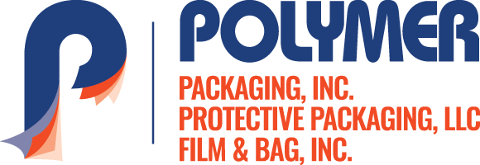

Contact: Chris Thomazin / 330-830-6046 / chris.thomazin@polymerpkg.com
Rod McGregor / 330-418-1124 / rmcgregor@crowlinc.com

FOR IMMEDIATE RELEASE

POLYMER PACKAGING ANNOUNCES ADIET PROVEN PROCESS WITH THE POLYMER WAY –
TO HELP ACHIEVE ITS VISION, GAIN TRACTION FOR SUCCESS AND GROWTH

Polymer Packaging has created a new quality initiative, the ADIETSM Proven Process. The ADIETSM Proven Process is a five-step process to improve the customer’s experience. The ADIETSM Proven Process works by applying the following steps:

• Assess – Collect information to understand the customer’s challenges and goals.
• Design – Take the data from the Assessment Stage and design a custom solution.
• Implement – A guaranteed production trial order is produced and tested.
• Evaluate – Review the solution to confirm all goals have been achieved.
• Track – Provide superior service continually improve upon the solution.

“Our ADIETSM Proven Process has helped us focus on the five components of our business, clarifying everyone’s roles and focusing on what’s important,” said Larry L. Lanham, CEO.

The message is a part of a new Entrepreneurial Operating System (EOS) within the company to help grow its revenue and achieve its vision for the future.

“We use our EOS as the basis for making decisions and to deliver on the company’s vision,” said Chris Thomazin, President. “We’ve gone from working hard to working smart. We have the right people in the right seats all working to exceed our customers’ expectations.” he added.

Polymer Packaging is a leader in developing flexible packaging solutions to the consumer products industry. For more information call 330-359-1421 or visit www.polymerpkg.com.
–30–

