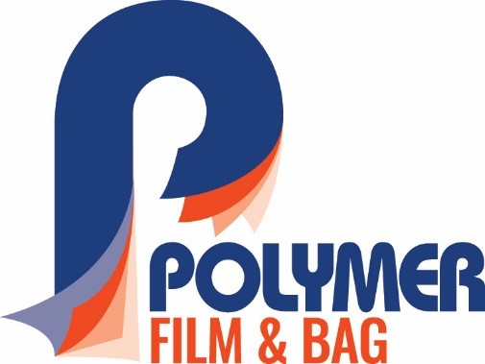

Contact: Chris Thomazin / 330-830-6046 / chris.thomazin@polymerpkg.com
Rod McGregor /330-418-1124 / rmcgregor@crowlinc.com

FOR IMMEDIATE RELEASE
March 23, 2022

STRETCH HOODER FILM FROM POLYMER FILM & BAG IS STRONGER
BUT THINNER, OFFERS MANY ADVANTAGES OVER STANDARD FILM

Massillon, OH—Polymer Film & Bag, a division of Polymer Packaging, Inc., is pleased to introduce Co-Polymer-X™ Stretch Hooder Film, a stronger but thinner light-weighted film alternative to standard mono-ply hooder film.
Co-Polymer-X™ Stretch Hooder Film is produced with proprietary resin formations on advanced, three-layer W&H co-extrusion lines, which give Polymer Film & Bag a unique advantage over other manufacturers. It provides dramatic strength enhancement, which saves packaging costs and reduces plastic consumption by 25-50 percent.
The multi-layered Stretch Hooder Film made by Polymer Film & Bag is a tubular film sealed on one end, while the other end stretches over a palletized load using specialized hooder equipment, offering complete protection for load containment.
“In a recent case study comparing Polymer Film & Bag to the incumbent film, a customer using 2,385,496 feet of hooder film per year reduced usage from 1 million to 700,000 lbs. annually and achieved $75,000-$250,000 in annual savings,” said Eric Howard, division president.
Polymer Film & Bag’s Stretch Hooder Film offers the following advantages:
• Protection on all five sides with superior holding force;
• Highest quality resins are utilized to create the strongest film;
• Best-in-class gauge control, which ensured a fixed price-per-pallet;
• SKU consolidation: Polymer’s stretch holder films can palletize a broader range of pallet sizes;
• Source reduction: Downgauging from 25-50 percent reduces packaging cost and is more sustainable;
• Standard “Me Too” and Co-Polymer-X formulations available.
Polymer’s Stretch Hooder Film is compatible with all major stretch hooding systems. It offers UV protection, anti-stat and anti-fog properties, and is available in clear, tinted or opaque film. Printing is available, and the film is recyclable.
Co-Polymer-X outperforms thicker-gauge mono-ply film in all tests including dart impact, tensile strength, tear resistance and elongation.
Polymer Stretch Hooder Film is used in a wide variety of industries including building materials, food and beverage, household appliances, corrugated, bricks and cement, and bags (chemical, fertilizer, minerals pellets and mulch).
For more information, call 330-359-1421 or visit https://www.polymerpkg.com.

(Photo cutline)

Our 3-Layer W&H co-extrusion line and proprietary resin formulations give us unique advantages over standard films.

--30--

