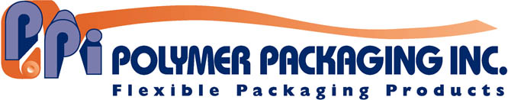

**8333 Navarre Road SE**

**Massillon, OH 44646**

**Website:** [**www.polymerpkg.com**](http://www.polymerpkg.com)

**Contact:** Rod McGregor / 330.418.1124 / [rodmcgregor@crowlinc.com](mailto:rodmcgregor@crowlinc.com)

May 22, 2018

**FOR IMMEDIATE RELEASE**

**(High Resolution image and Caption Included on Page 2)**

**POLYMER PACKAGING OFFERS INNO-LOK TECHNOLOGY**

**FOR COST-EFFECTIVE, USER-FRIENDLY PACKAGING**

**Massillon, OH—** As a licensed provider of INNO-LOK® technology, Polymer Packaging, Inc. offers the patented INNO-LOK® Pre-Zippered Film for barrier and non-barrier packaging applications. It is a patented product and method for attaching reclosable fasteners transversely to packaging films, thereby producing a roll of pre-zippered film.

“INNO-LOK® Pre-Zippered Film literally changed the way zippers are applied to packaging,” explained Bob Babich, Vice President of Sales and Marketing. “The process creates pre-zippered roll-stock, which can then be used in vertical form-fill-seal applications, creating a versatile, reliable, and cost-effective reclosable bag with little capital expenditure.”

INNO-LOK® can be used with multiple opening styles to support a diverse selection of items like frozen food, grains, seasonings, drink mixes, snack food, pet food, etc. The reclosable feature can be applied as Front Panel, Bag Top, and Pour & Lok™ designs (re-closable pour spout). The versatility of INNO-LOK® film is what sets it apart from traditional re-closable packaging options.

Polymer Packaging is a leader in developing flexible packaging solutions for the consumer products industry. For more information call 330-359-1421 or visit <https://www.polymerpkg.com/polymer-packaging-inc>.

˗30˗

Photo: INNO-LOK® Pre-Zippered Film from Polymer Packaging, Inc.

Caption: INNO-LOK® Pre-Zippered Film from Polymer Packaging, Inc.

