FOR IMMEDIATE RELEASE



Safeguard Announces a Quick Ship Standard Inventory Program
The most popular Hi-Traction Step Covers ship in 48 hours or less

STREETSBORO, Ohio – (June 12, 2010) – Safeguard Technology, leading innovator of anti-slip solutions, now offers a Quick Ship Standard Inventory Program that is comprised of Safeguard® Hi-Traction anti-slip Step Covers in the most popular sizes, grits and colors.

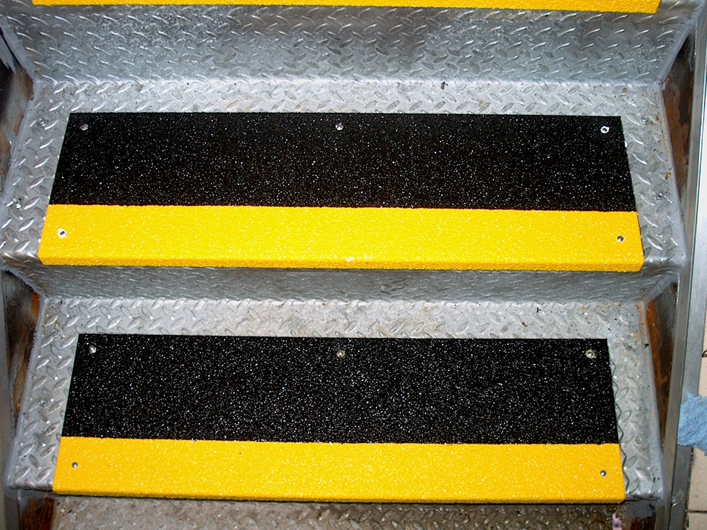
The standard inventory step covers can be shipped within 48 hours to help distributors and customers with their immediate anti-slip needs. Safeguard’s superior Hi-Traction Step Covers are available in a complete range of the most common standard and metric sizes. Pre-drilled holes are optional and screws, bolts and adhesives can be included to make installation easier.

Safeguard’s Quick Ship Standard Inventory covers are made from the same high-quality anti-slip materials as all of its Hi-Traction anti-slip covers. For more information about the Quick Ship Standard Inventory Program, call 1-800-989-1695.
Safeguard’s most popular Hi-Traction Safety Covers ship
in 48 hours or less with the Quick Ship Standard
Inventory Program.

About Safeguard Technology:
Safeguard Technology, headquartered in Streetsboro, Ohio, is a leading innovator in the safety industry, and is dedicated to the design, development and manufacture of superior safety products for the prevention of slips and falls. Safeguard’s products are utilized worldwide and have been considered to be the first choice for application in the offshore oil and gas industry.

For product questions, contact Safeguard Technology Customer Service at 1-800-989-1695 or visit www.safeguard-technology.com. Downloadable press releases and images are available on Safeguard’s online news archive at www.editorpressroom.com/safeguard.

-more-

Contact:
Erick Schuetz
Safeguard Technology
330-995-5200 ext. 222
erschuetz@safeguard-technology.com

Abbey Linville
Crowl, Montgomery & Clark
330-494-6999 ext. 207
alinville@crowlinc.com

###

